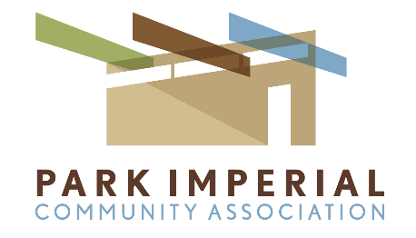

PICA Homeowners,

As you know during these unusual, trying times we find ourselves adhering to self-isolation, social distancing and safe health/hygiene practices as best we can in an effort to protect ourselves and those around us. As a result of this our PICA Annual Meeting (3/28/20) was limited to a teleconferencing session with participation by board members only.

The PICA Annual Election saw more than the (26) returned ballots needed in order to reach a per the rules quorum in certifying the 2020 Annual election for Patrick Howard and myself. It is very much appreciated and I want to sincerely thank you for the level of and continued strong support received.

This past term saw a continuation of efforts that have truly brought a renaissance to our Park Imperial North community:
- Complex-wide improvements to numerous unit exteriors included MCM enhancements as to entry doors, accent color, lighting fixtures and more.
- Many owners partnered with the HOA in exterior beautification by removing old metal security doors and metal window bars, removing rotting roof slats and unsightly patio/window shades.
- Exterior maintenance/restoration continued in the repair of crumbling & broken wall stucco, replacement of exterior wood trim, caps and sills and extensive painting throughout the complex.
- Extensive effort has also been invested in the beautification of the grounds with many of our common spaces, corridors and cut-outs having been dramatically upgraded with attractive new plants, rocks and decorative stone throughout.
- Newly charged roofers servicing PIN with an annual roofing maintenance program now addressing rotational roofing a building at a time verses a unit at a time.

Our collective efforts reached a crescendo in the hosting of the successful Modernism Week PIN Neighborhood Tour, first ever to be held at PIN on 2/17/20. We learned so much from the experience and will consider hosting others in the future.

None of this would have been possible without the generous efforts and participation of PICA owners, committee members and volunteers. Hats off to all of you in helping make PIN such a unique, wonderful place to live and be a part of.

Lastly, I ask that you always strive to be a good neighbor. This includes respecting all of the PICA rules including the maintenance of your pets and service animals: 1) On leash at ALL times 2) Avoidance of common spaces/pool areas (restricted to walk-thru only) and 3) Always to picking up after pets. AND… It very much means Neighbors helping Neighbors - please do take the time to call on and assist those amongst us who may be less able to navigate these trying times.

We are all in this together.

The very best to you and your families,

Robert Clawson
President
Park Imperial Community Association

